Experiment-12

Cursors

1.Create a table with attributes students and marks

2.Insert values into tables

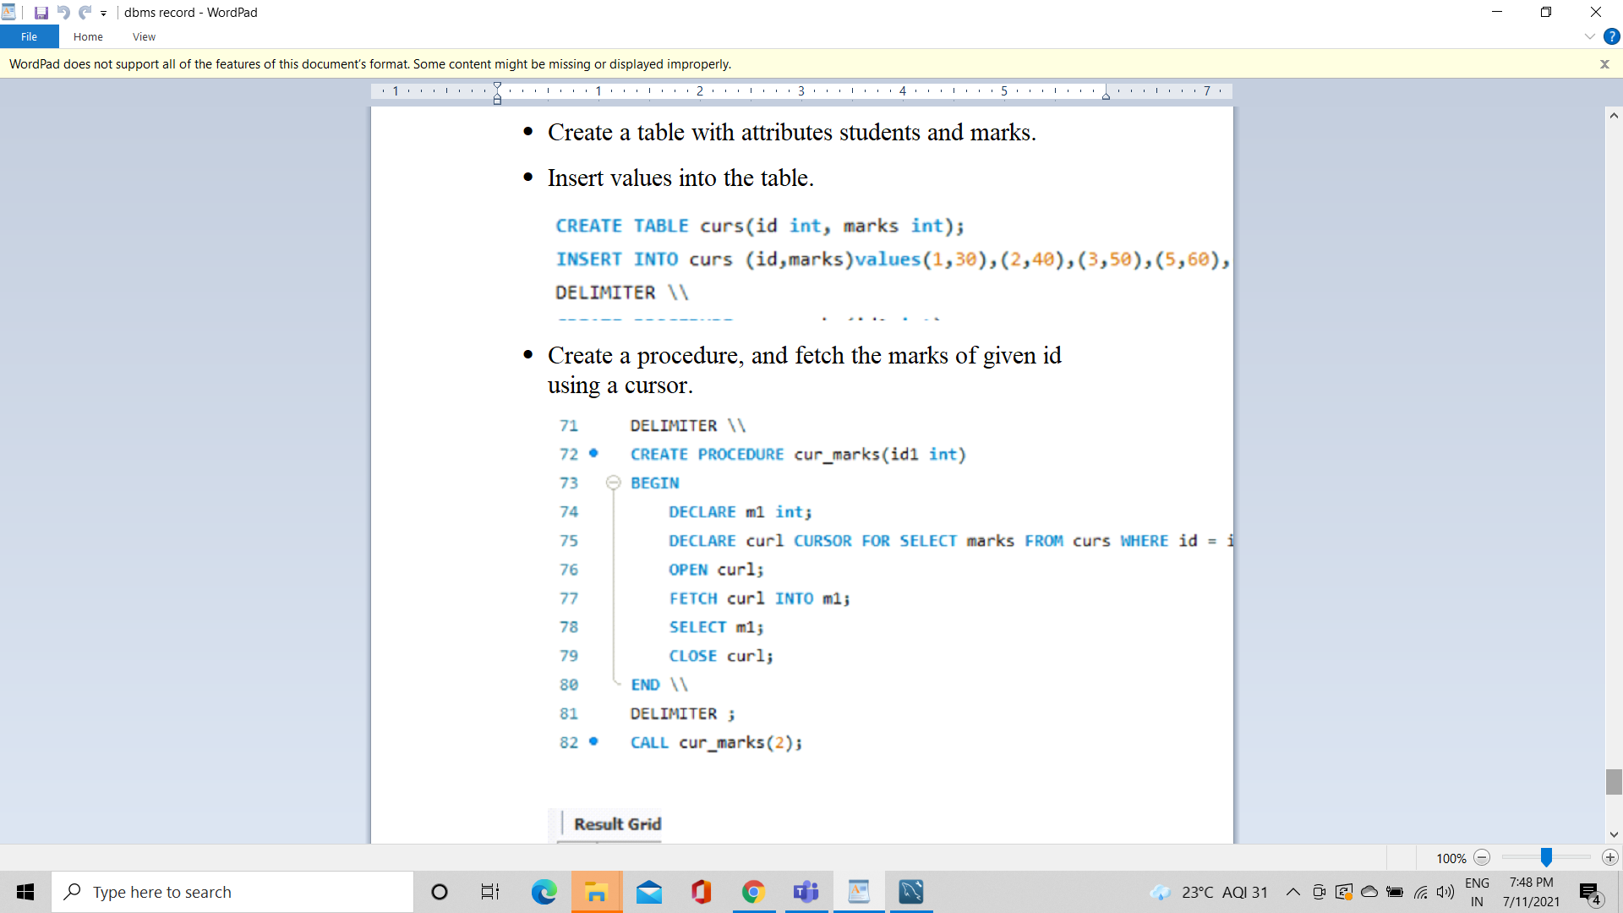

3. Create a procedure and fetch the marks of given id using a cursor



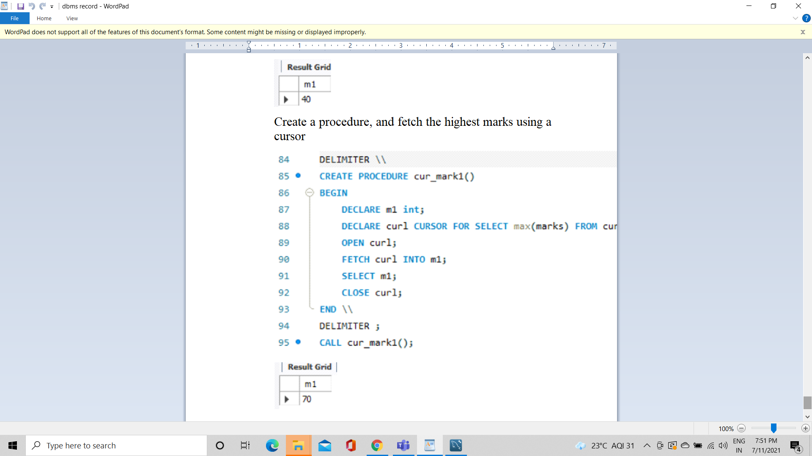

4. Create a procedure and fetch the highest marks using a cursor



